**Node/Sensor Information**

* **Total number of Node: 90**
* **Nodes with Sound sensor: 63**
* **Nodes with PM2.5 sensor: 16**
  + **Pm25_atm: 1**
  + **Pm2_5: only 2 are giving data.**
* **Nodes with No2 sensor: 33**

|  |  |  |  |  |  |
| --- | --- | --- | --- | --- | --- |
| Data | Sensor | Parameter | Hrf_unit | Hrf_minval | Hrf_maxval |
| No2 | no2 | concentration | ppm | 0 | 20 |
| PM2.5 | pms7003 | pm25_atm | mg/m^3 | 0 | - |
| opc_n2 | pm2_5 | mg/m^3 | 0 | - |
| Sound level  (Sound pressure) | spv1840lr5h_b | intensity | dB | 0 | 121 |
| microphone | octave_total_intensity | dB | 0 | 140 |

* `hrf_unit` - Physical units of HRF value.

* `hrf_minval` - Minimum HRF value according to datasheet. Used as lower bound in range filter.

* `hrf_maxval` - Maximum HRF value according to datasheet. Used as upper bound in range filter.

**Sensor Info**

no2: <https://github.com/waggle-sensor/sensors/blob/master/sensors/chemsense/no2.pdf>

pms7003: <https://github.com/waggle-sensor/sensors/blob/master/sensors/plantower/pms7003.pdf>

opc_n2: <https://github.com/waggle-sensor/sensors/blob/master/sensors/opc/opcN2.pdf>

spv1840lr5h_b: <https://github.com/waggle-sensor/sensors/blob/master/sensors/airsense/spv1840lr5h-b.pdf>

* Newly added microphone provides various level of data (will figure out about the octave.)

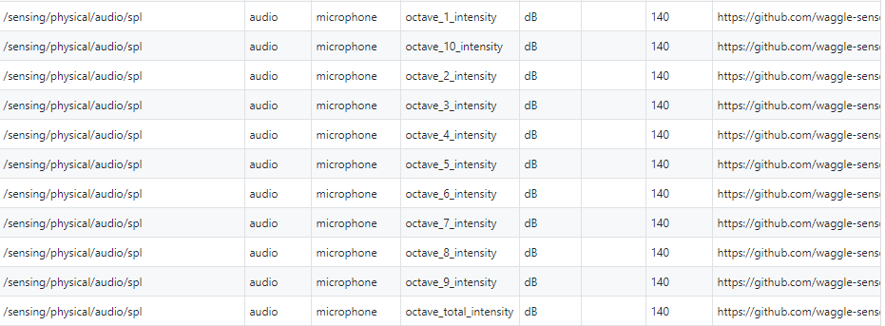

**API**

* Get list of nodes.

|  |  |
| --- | --- |
| API | **GET:** 34.229.219.45:9000/api/info/nodes |
| Return | Number of nodes, Location(Lat./Lon./Address) of each node |
| Return format |  |

* Get information of a node.

|  |  |
| --- | --- |
| API | **GET:** 34.229.219.45:9000/api/info/nodes/[node_id] |
| Return | Node ID, Location (Lat./Lon./Address) of the node, Existence of sensors |
| Return format |  |

* Get list of nodes that have a sound sensor (spv1840lr5h_b).

|  |  |
| --- | --- |
| API | **GET:** 34.229.219.45:9000/api/info/sound |
| Return | List of nodes with a sound sensor, Number of nodes |
| Return format |  |

* Get list of nodes that have pm2.5 sensors.

|  |  |
| --- | --- |
| API | **GET:** 34.229.219.45:9000/api/info/pm25 |
| Return | List of nodes with a pm2.5 sensor, Number of nodes |
| Return format |  |

* Get list of nodes that have a no2 sensor (no2).

|  |  |
| --- | --- |
| API | **GET:** 34.229.219.45:9000/api/info/no2 |
| Return | List of nodes with a no2 sensor, Number of nodes |
| Return format |  |

* Get the latest value of the sensor from nodes.

|  |  |
| --- | --- |
| API | **GET:** 34.229.219.45:9000/api/value/ |
| Return | Latest data from nodes. |
| Return format |  |